# Importing VM's For Class

Lab Goal: Learning how to import Virtual Machine appliances for class

Lab Requirements:

* Access to Teams
* VMware Workstation Pro
* Windows 10 or Windows 11 PC

Contents

Importing VM's For Class 1

Part 1: Importing Debian in VMware 3

Task 1: Importing Debian OVA. 3

Step 1: Open teams and download Debian ova appliance. 3

Step 2: Double click on Debian_12.5.ova 3

Step 3: Assign VM name and location. 4

Step 4: Wait for import to complete. 5

Task 2: Verification 5

Step 1: Verify that VM is imported correctly. 5

Step 2: Start Debian VM and access Internet. 6

Part 2: Importing Kali in VMware 7

Task 1: Importing Kali OVA. 7

Step 1: Open teams and download Debian ova appliance. 7

Step 2: Double click on kali-linux-2024.2-vmware-amd64.ova.ova 7

Step 3: Assign VM name and location. 7

Step 4: Wait for import to complete. 7

Task 2: Verification 7

Step 1: Verify that VM is imported correctly. 7

Step 2: Start Kali VM and access Internet. 7

## Part 1: Importing Debian in VMware

### Task 1: Importing Debian OVA.

#### Step 1: Open teams and download Debian ova appliance.

#### Step 2: Double click on Debian_12.5.ova

You will be asked to select default application to open ova if you have never done this before.

Select VMware workstation and choose to always open .ova with it.

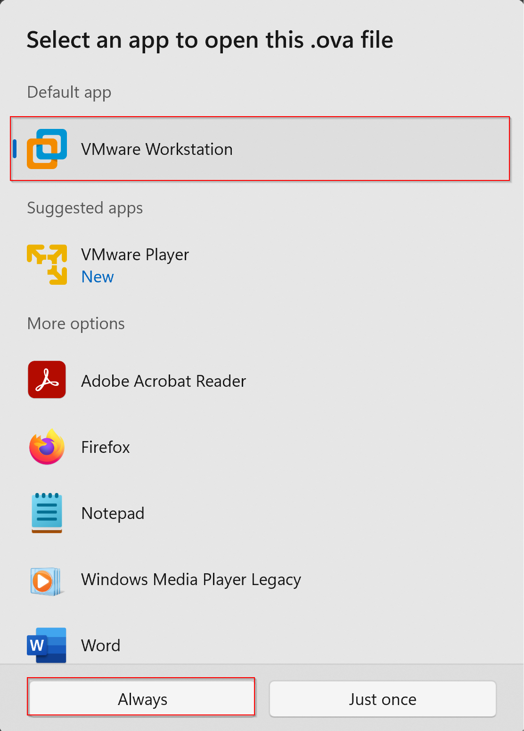

#### Step 3: Assign VM name and location.

1. Assign VM name.
2. Change location accordingly.
3. Click on Import button.

#### Step 4: Wait for import to complete.

### Task 2: Verification

#### Step 1: Verify that VM is imported correctly.

Locate imported Debian VM in your VM library

#### Step 2: Start Debian VM and access Internet.

To Log in please use following credentials.

Username: **student**

Password: **student**

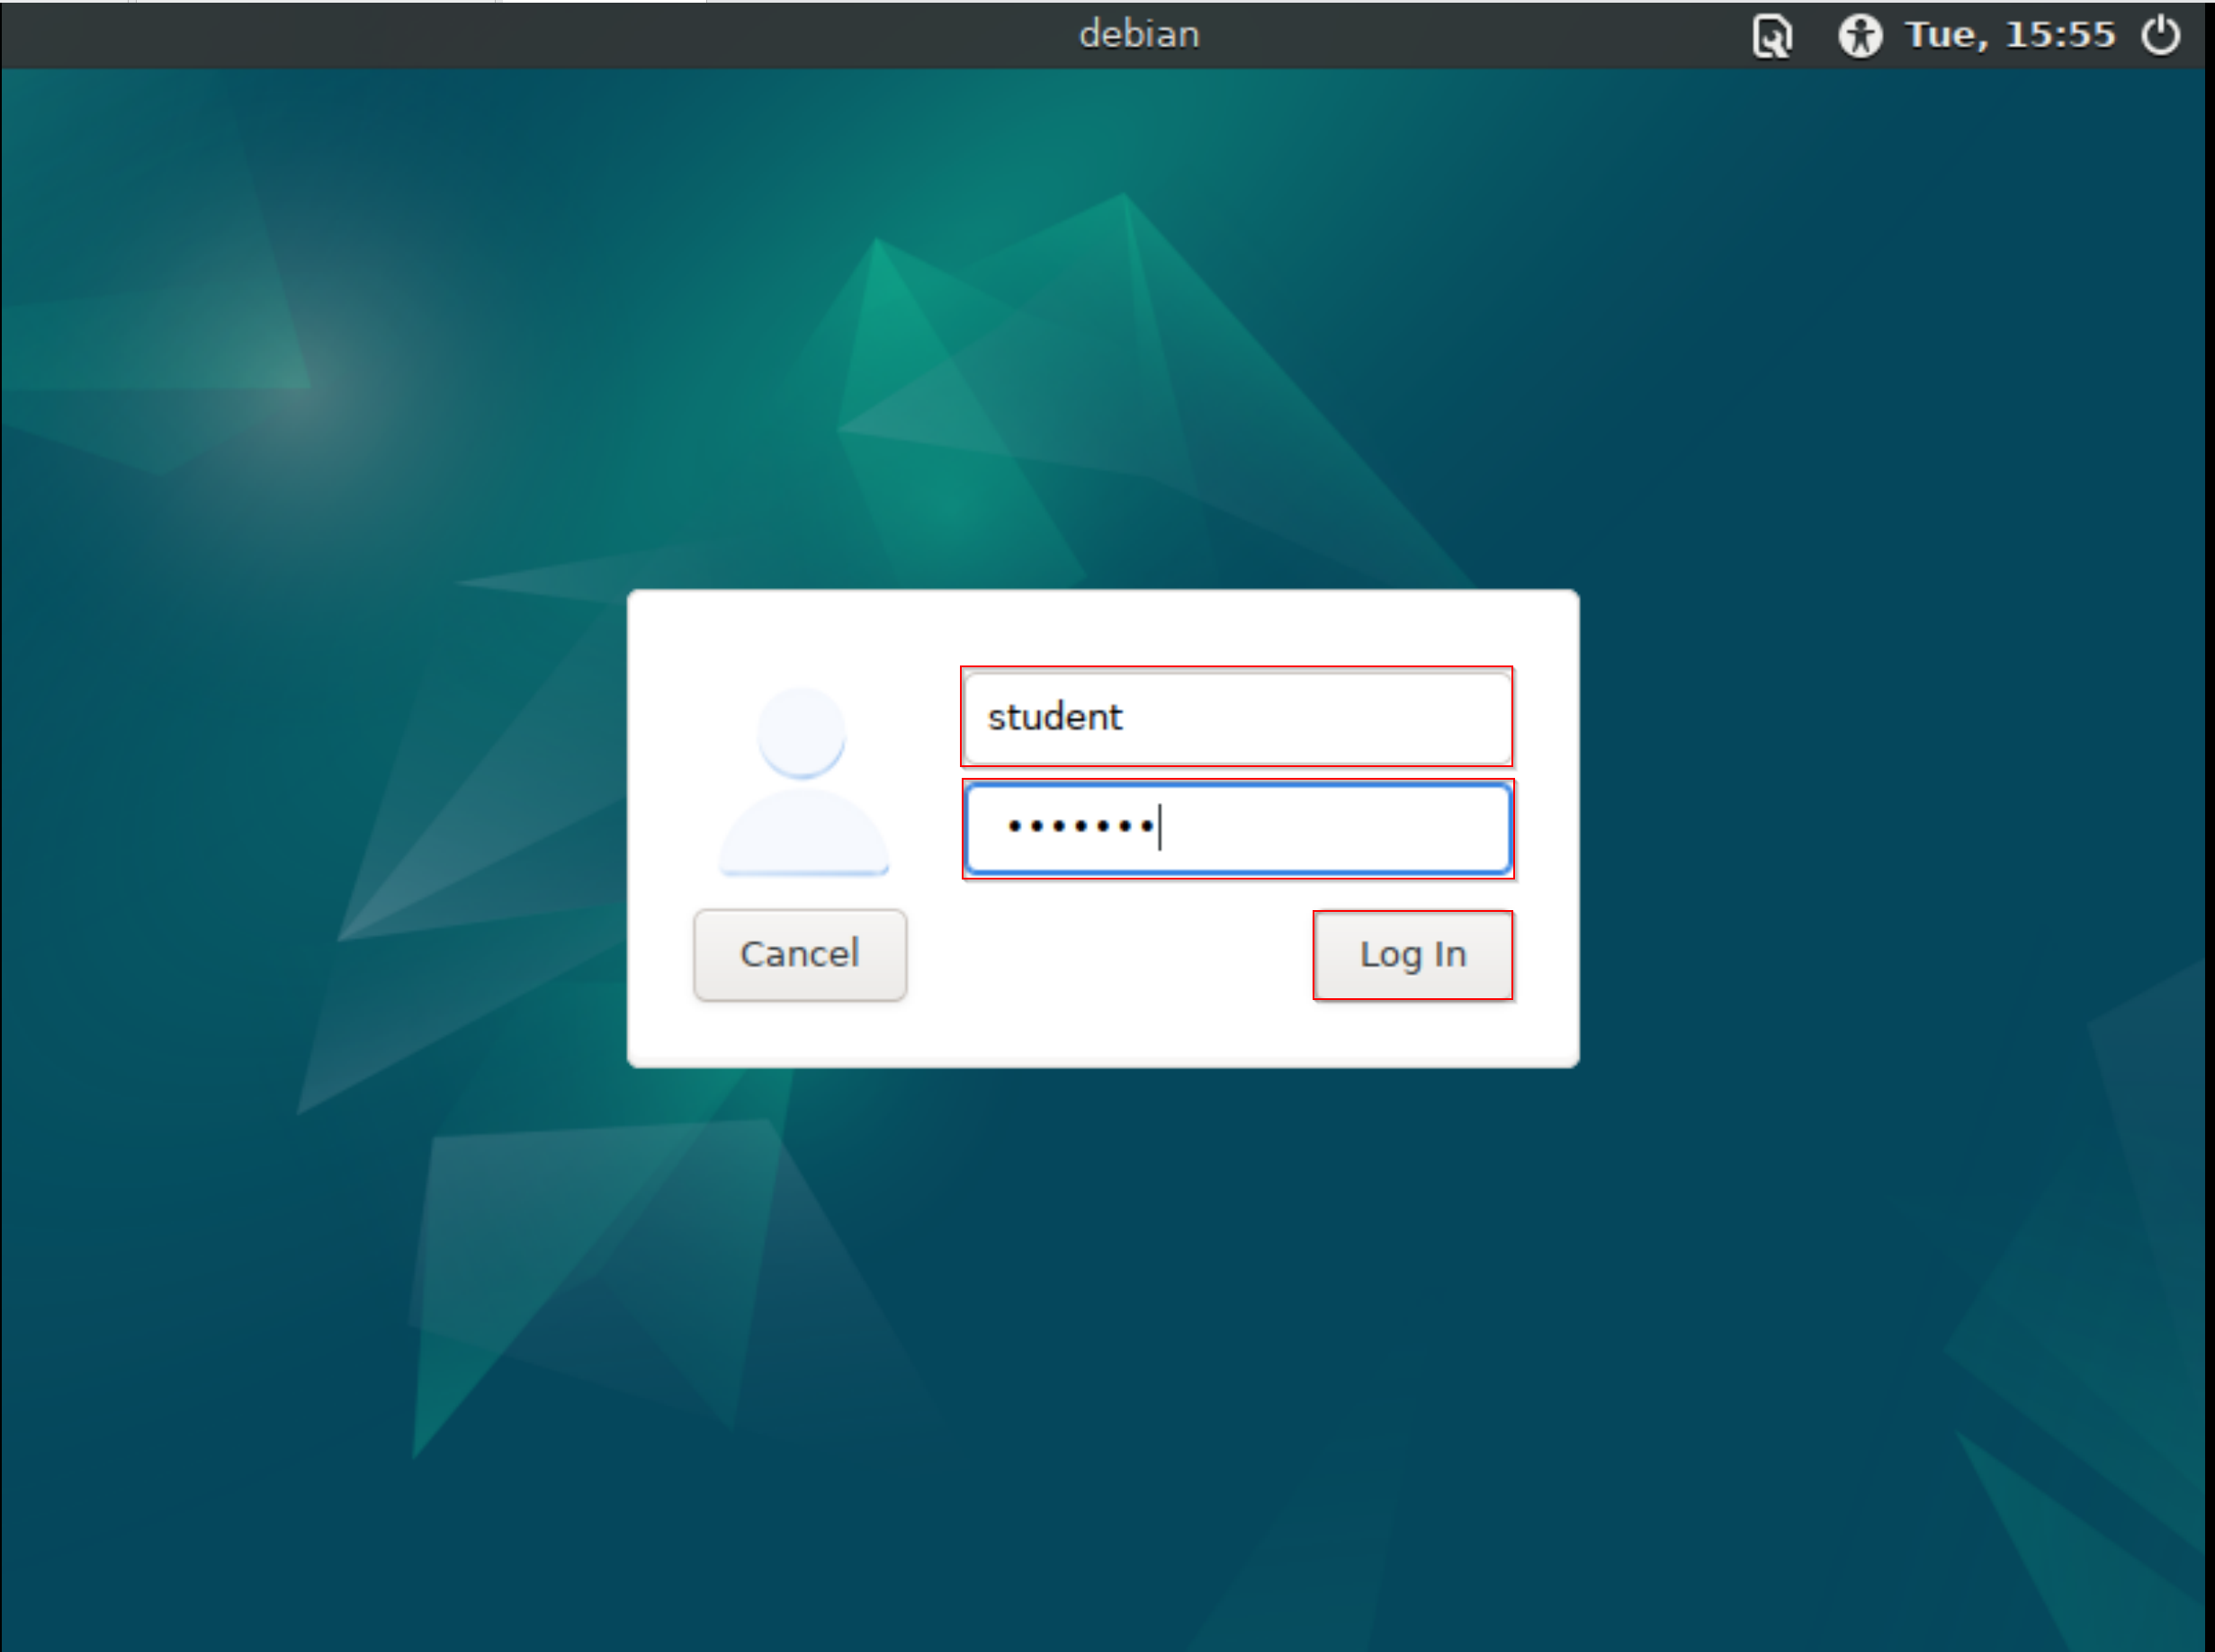

Open web browser and navigate to [www.google.com](http://www.google.com)

## Part 2: Importing Kali in VMware

Please follow same steps you have used to import Debian

### Task 1: Importing Kali OVA.

#### Step 1: Open teams and download Debian ova appliance.

#### Step 2: Double click on kali-linux-2024.2-vmware-amd64.ova.ova

#### Step 3: Assign VM name and location.

#### Step 4: Wait for import to complete.

### Task 2: Verification

#### Step 1: Verify that VM is imported correctly.

#### Step 2: Start Kali VM and access Internet.

## Part 3: IMPORTANT steps for keeping your VM up to date.

**Every time you start Debain, or any other Debian based distribution please make sure to update your local repository list and upgrade all outdated packages.**

sudo apt update && sudo apt upgrade -y